**About the Program**

This “Autoshedding Control System” is a program solely written in C. It is a simple console program that lets the user know about the current state of power supply of the location he’s currently opening the program. It is mainly targeted to the Nepalese users who compulsorily need to get informed about the status of power supply in their area.

It doesn’t just displays the current state of power supply in the area, but also lets the user define his own schedule or edit the timings himself.

The program uses self-created graphics library and other header files. Although the program has been made very simple, we believe that users can find what they’re looking at with this program.

**Using the Program**

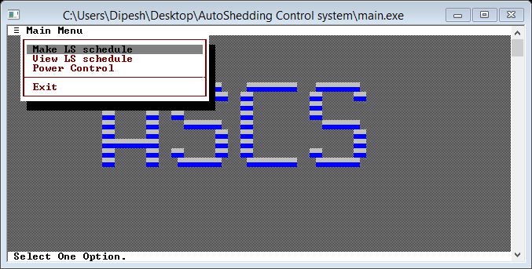On running the executable file main.exe, a console window appears which looks like

On entering the Make LS schedule, a screen similar to below appears.

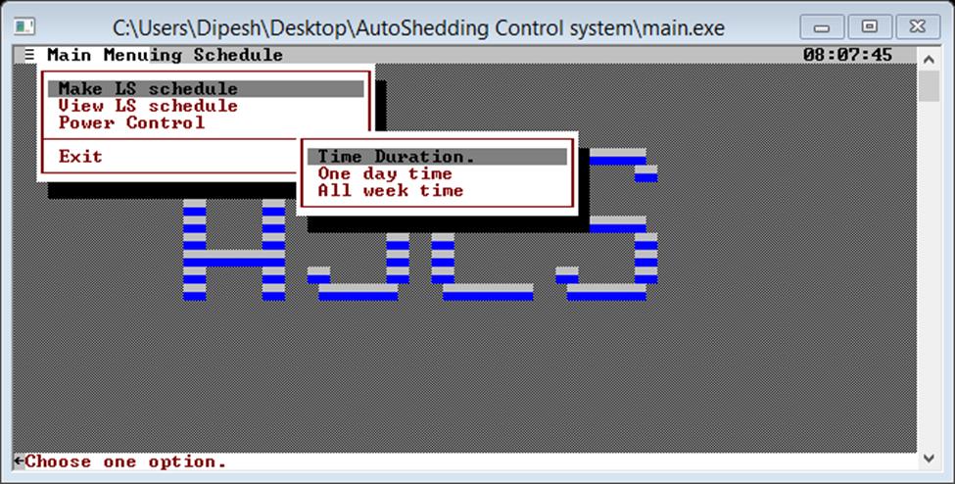

Here the user is allowed to manually enter the timings and generate his own loadshedding schedule.

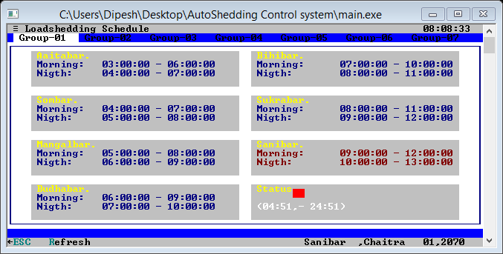The user can now view his self created schedule or the default schedule on entering into the View LS schedule menu. The sample looks like

One good feature of this program is that the user can force close or open the status of a particular loadshedding group on entering into the Power Control menu:

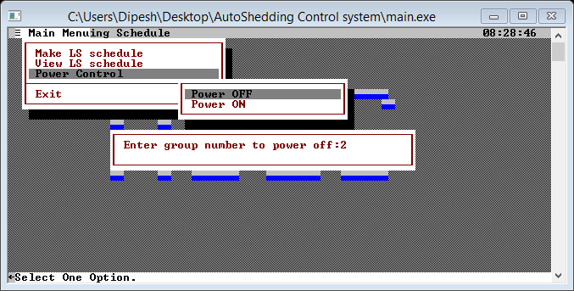

The screenshot above is a case when the user wants to force close the loadshedding status of group 2. After this, the status of the loadshedding in group 2 changes.